Name: K. PRAVEEN KUMAR

DAY-4 ASSIGNMENT(07-12-2023)

Creating and inserting data into Table:

‘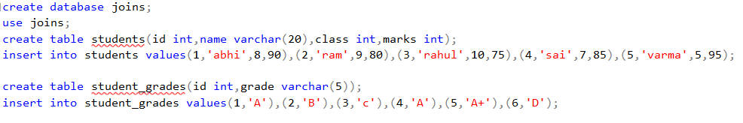

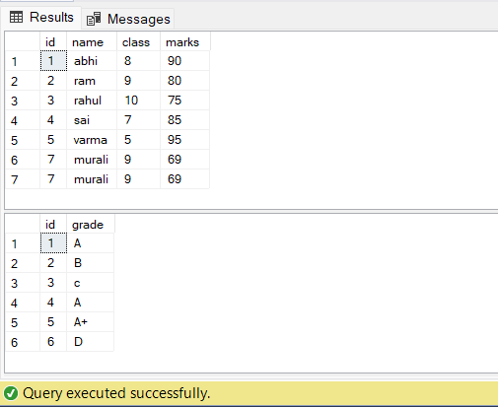

Inner join:

select students.name,students.class,students.marks,student_grades.grade

from students inner join student_grades on students.id=student_grades.id;

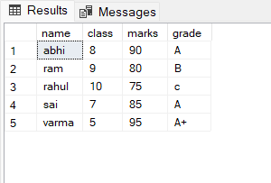

Left join:

select students.id,students.name,students.class,students.marks,student_grades.grade

from students left join student_grades on students.id=student_grades.id;

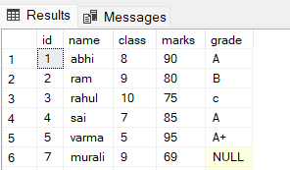

Right join:

select students.name,students.class,students.marks,student_grades.grade

from students right join student_grades on students.id=student_grades.id;

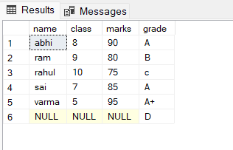

Full join:

select students.name,students.class,students.marks,student_grades.grade

from students full join student_grades on students.id=student_grades.id;

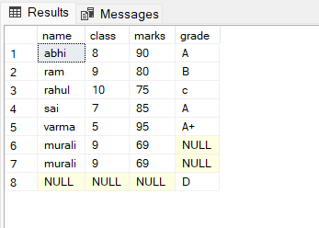

Cross join:

select students.name,students.class,students.marks ,student_grades.grade

from students cross join student_grades ;

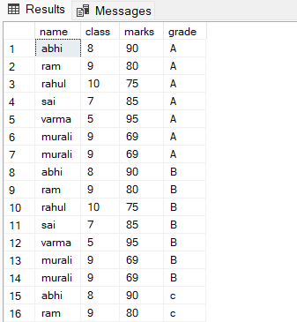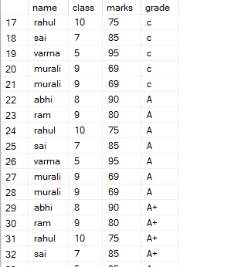

**String Functions:**

SELECT ascii ('name');

SELECT char (75);

SELECT len ('training');

SELECT lower ('JOHN');

SELECT REPLACE ('country', 'y', 'ies');

SELECT reverse ('what');

SELECT str (134.56,2,1);

SELECT upper ('Praveen');

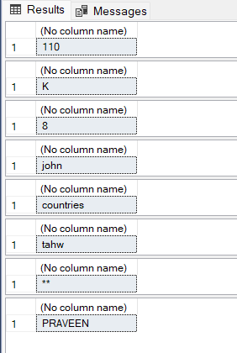

Date Functions:

select getdate();

SELECT dateadd (mm, 2, '2010-02-03');

SELECT datediff ( month, convert (datetime, '2006-05-06'), convert ( datetime, '2009-01-01'));

SELECT datediff (day, convert (datetime, '2006-05-06'), convert ( datetime, '2009-01-01'));

SELECT datediff ( year, convert (datetime, '2006-05-06'), convert ( datetime, '2009-01-01'));

SELECT datepart (mm, '2008-05-01');

SELECT datepart (dd, '2008-05-01');

SELECT datepart (yy, '2008-05-01');

SELECT day ( '2010-03-21');

SELECT month ('2007-04-03');

SELECT year ( '2011-04-17');

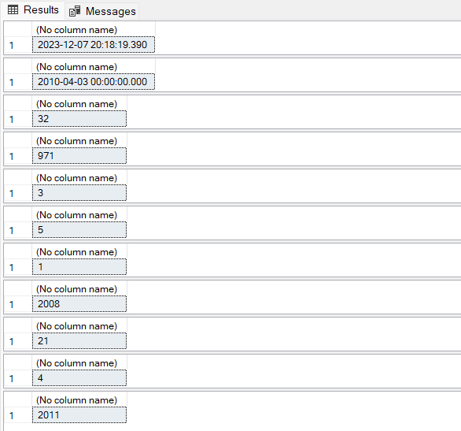

Mathematical Functions:

select abs(-77); /**retruns absolute value**/

select sin(1.5);

select ceiling(14.6);

select exp(5);

select floor(16.857);

select log(10.5);

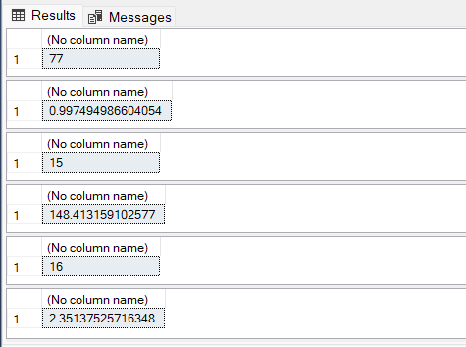

Rank Functions:

select id,name, row_number() over (order by name) from students;

select id,name,rank() over (order by marks desc) as rank from students;

select id,name,dense_rank() over (order by marks asc) as rank from students;

select id,name,class,NTILE(5) over(order by marks desc) as rank

from students where marks>=80;

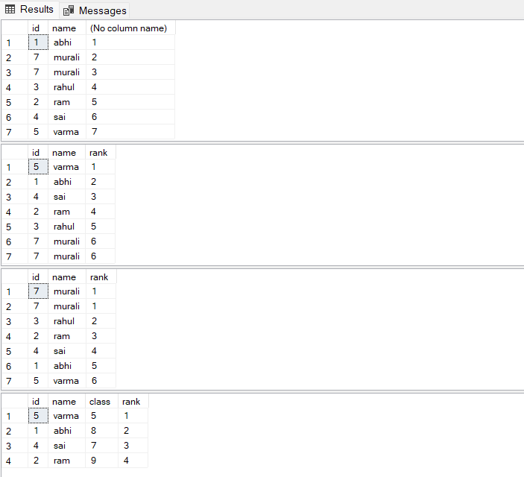

System Functions:

select HOST_ID() as 'hostid';

select SUSER_ID() as sid;

select user_id() as USERID;

select db_name(5) as databasename;

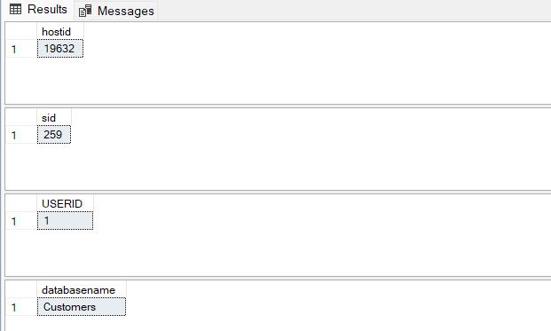

Aggregate Functions:

select 'Average_marks'=avg(marks) from students;

select 'unique mark'=count(distinct marks) from students;

select 'min mark'=min(marks) from students;

select 'max mark'=max(marks) from students;

select 'sum of marks'=sum(marks) from students;

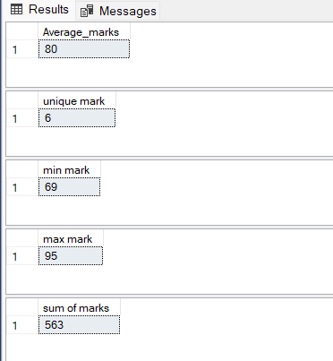

Group by:

select name,count(marks),marks

from students

where id between '1' and '4'

group by name,marks;

